**Assignment No. 5**

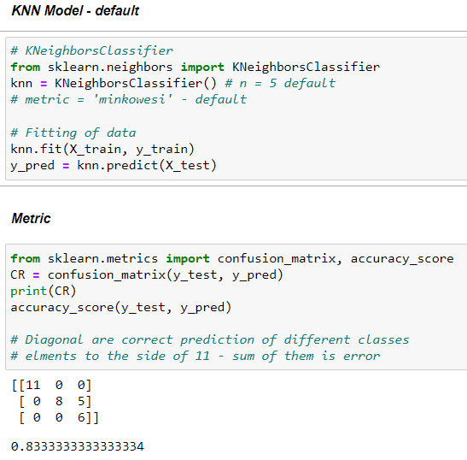

Using Default values in sci-kit learn module for KNN, it uses ‘minoweski’ metric with 5 neihghbour we get fairly good accuracy of 83 %.

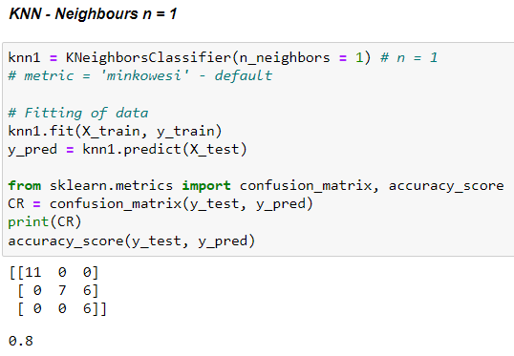

For KNN model with neighbours n = 1, accuracy is reduced to 80% which is also not bad. Using default metric

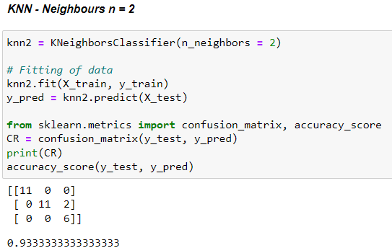

Now we take neighbour n = 2 our accuracy jumps up 93 % which is very good.

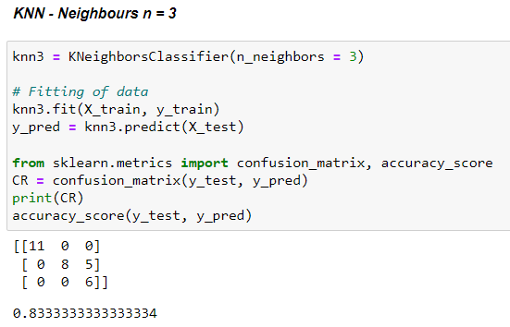

Taking n = 3 our accuracy again reaches to 83% which will be same until we take n =70-80, then the accuracy will reduce drastically.

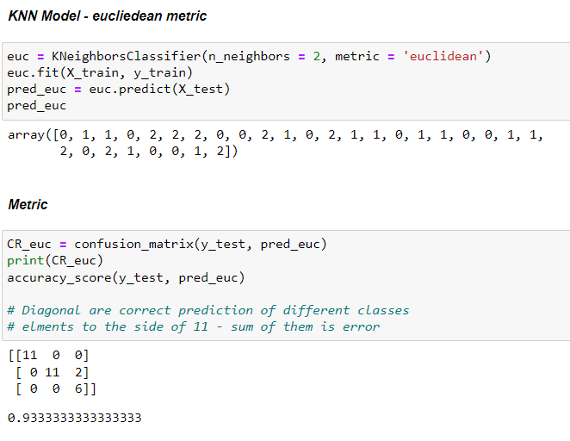

Same model accuracy for Euclidena metric and minkoweski metric.